TIPS FOR Neural Network

There's one additional rule of thumb that helps for supervised learning problems. The upper bound on the number of hidden neurons that won't result in over-fitting is:

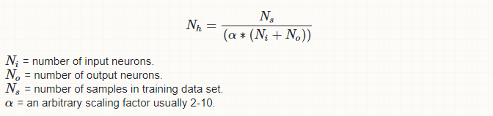

* The number of hidden nodes in each layer should be somewhere between the size of the input and output layer, potentially the mean.